**Predicting Survival on the Titanic**

**Name: هادي احمد عبدالسلام عبدالحميد**

**Id: 20191700728**

**Dpt.: CS**

**Section: 6**

# Data Exploration:

1. Count the number of passengers by survival status.

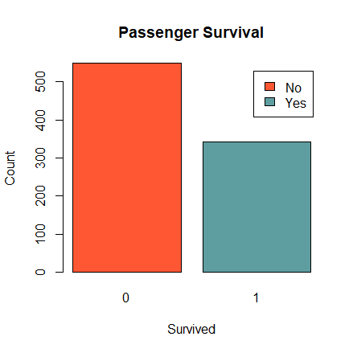

1. Create a histogram of passenger age.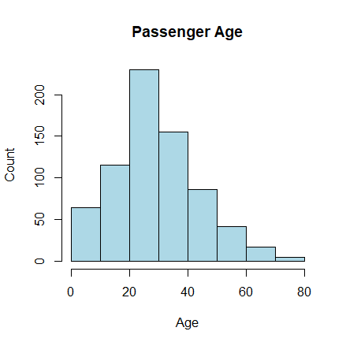
2. Bar plot for categorical variables: For variables like "Sex" and "Embarked", you can create a bar plot to see the proportion of survivors for each category. Here's an example code for the "Sex" variable:

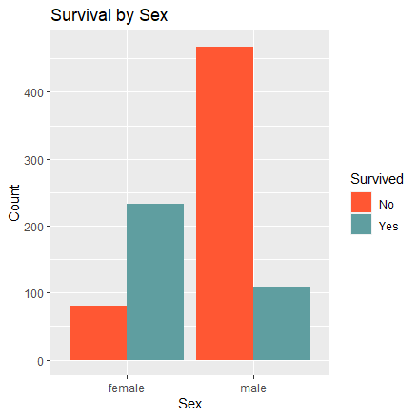

1. Histogram for continuous variables: For variables like "Age" and "Fare", you can create a histogram to see the distribution of survivors and non-survivors. Here's an example code for the "Age" variable:

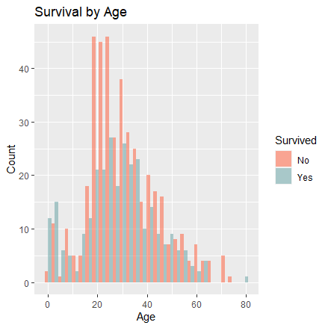

1. Box plot for continuous variables and categorical variables: For variables like "Pclass" and "Embarked", you can create a box plot to see the distribution of survivors and non-survivors for each category. Here's an example code for the "Pclass" variable:

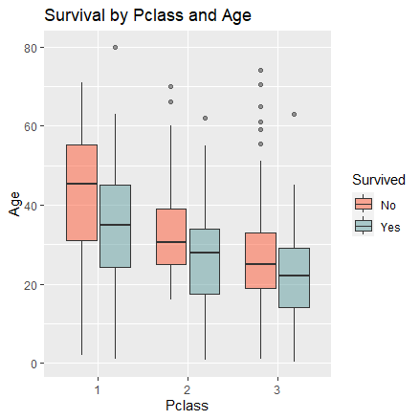

# Preprocessing

Based on the Data Exploration this preprocessing is done:

* Dropped unnecessary columns like "PassengerId", "Name", "Ticket", "Cabin", and "take-off".
* Applied one-hot encoding for the "Sex" column.
* Changed some columns into factors like "tack. off" and "Pclass".
* Filled the null values in both the "Age" and "Fear" columns with the mean.

# Used Models

* Random Forest Model
* Logistic Regression
* Naive Bayes Model

# Results

This Results is Based on the Kaggle summations of the Test data.

The **Random Forest** Model achieved the **highest accuracy** with a score of **79%**, followed by **Logistic Regression** with a score of **76%**, and **Naive Bayes** Model with a score of **74%**.